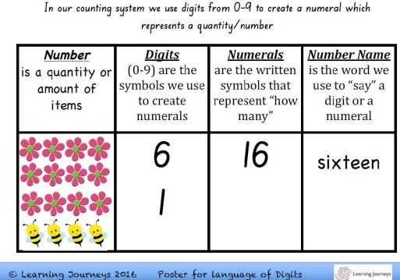
Developing Number Sense R-4:
What are the rules for Base Ten?

Do your learners have a strong foundation in how our numeration system works? Do they know the three patterns of our Base Ten system, the rules for reading and writing numerals and the rules for counting collections?
Do you as the educator have a deep understanding of how these concepts work and also how to teach them in a way that leads to deep understanding for all?
This session is designed to support educators to:
- Further develop their own understanding and confidence with the foundational aspects of number sense (as described in the Australian Curriculum)
- Look at the range of audit tools we can use (including the Big Ideas in Number) to work out where children are at with various aspects of the “rules for Base Ten” as described within the Number and Place Value Sub-Strand
- Exploring a wide range of practical strategies and activities that can be targeted to meet the specific needs of each learning point within the Base Ten system
- Increasing their capacity to recognise significant progress indicators and then plan for future learning

