Designing Mathematics and Numeracy learning in the Preschool Setting:
Mathematising our “playspaces/playscapes” through the lens of the Indicators of Numeracy
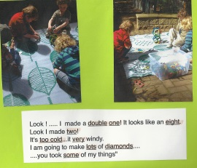  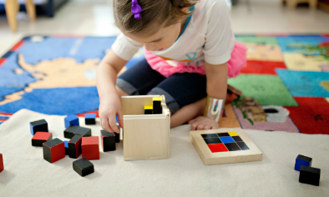  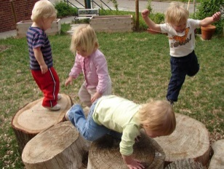 | One of the strategies for “intentionally teaching” mathematics and numeracy in a preschool setting is to “mathematise” all of our playspaces/playscapes. If this is something that you and your site have been working on, then this will be the session for you! It will provide the opportunity to share and explore some resources to support your thinking in this area.  

