Using children’s literature to drive your mathematics learning in 2022! |   With  Mike Chartres
Mike Chartres has been in education in South Australia for the last forty five years. In this time he has worked extensively as a classroom teacher, in school leadership, as a curriculum officer and writer and for the last two decades as an academic in teacher education with the University of South Australia. He brings passion and enthusiasm for his areas of expertise and an outstanding breadth of knowledge and understanding about how to put them into practice in a classroom setting

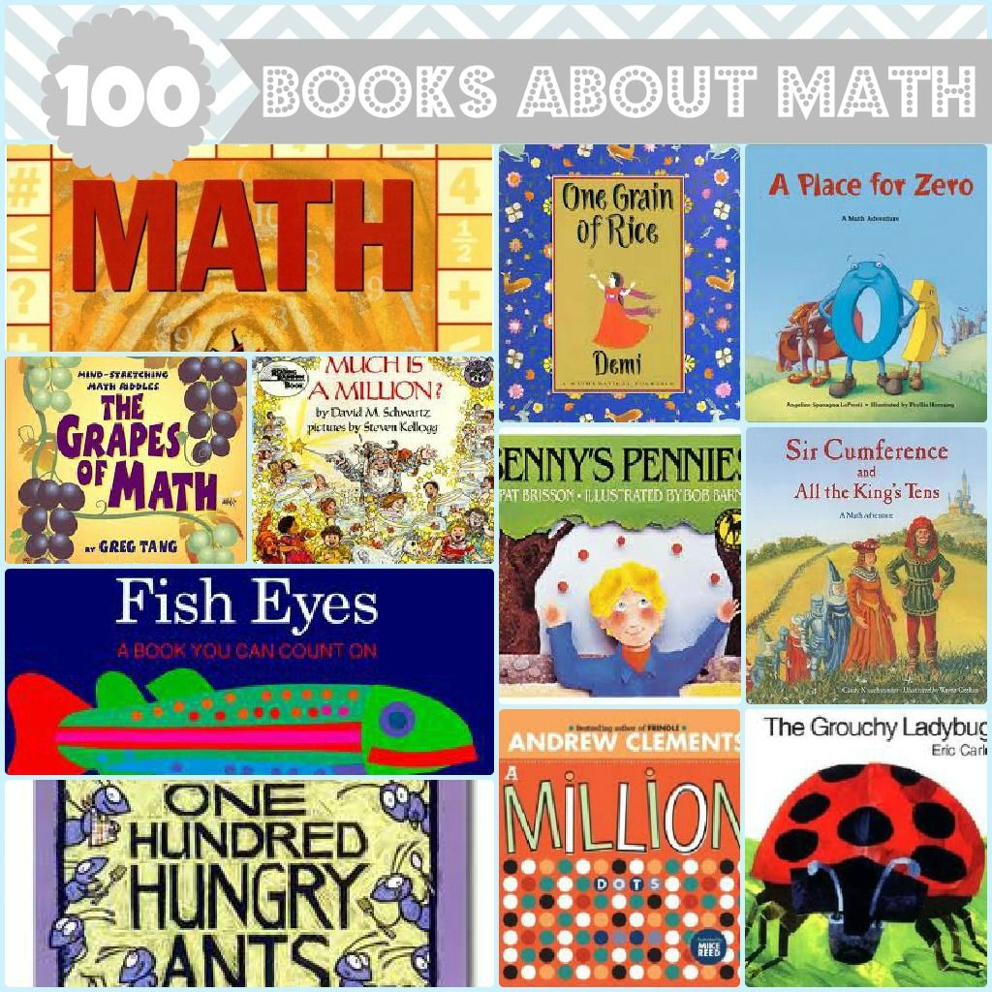 | There are picture books and novels to stimulate and drive learning in every strand of mathematics.  Do you know what some of the best ones are and how you can use them to craft powerful and engaging learning experiences with and for learners?  Want to immerse yourself in mathematics reading heaven – then come and join the conversation!

